# Delegation-Mendix

1.Download “ Delegation Module” from marketplace.

([Mendix Marketplace - Delegation Module](https://marketplace.mendix.com/link/component/118458))

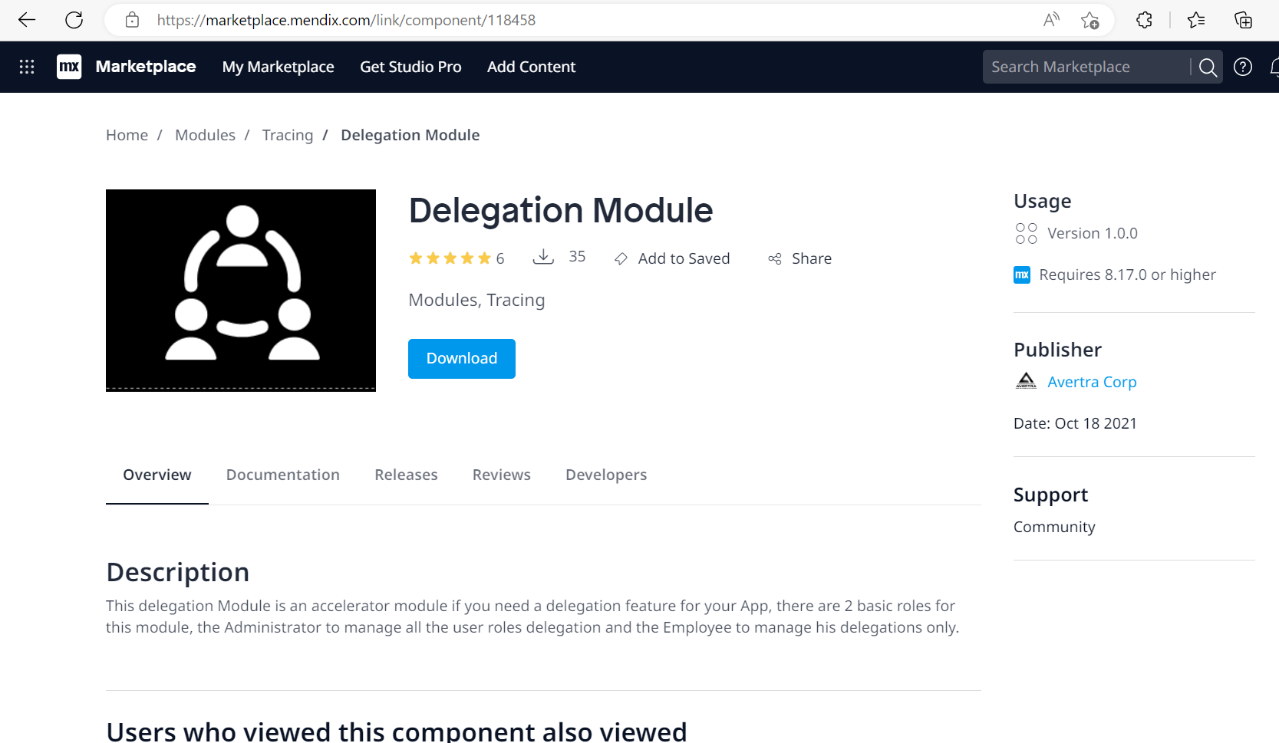

2.Download “AuditTrail ” module from marketplace.

([Mendix Marketplace - Audittrail](https://marketplace.mendix.com/link/component/138))

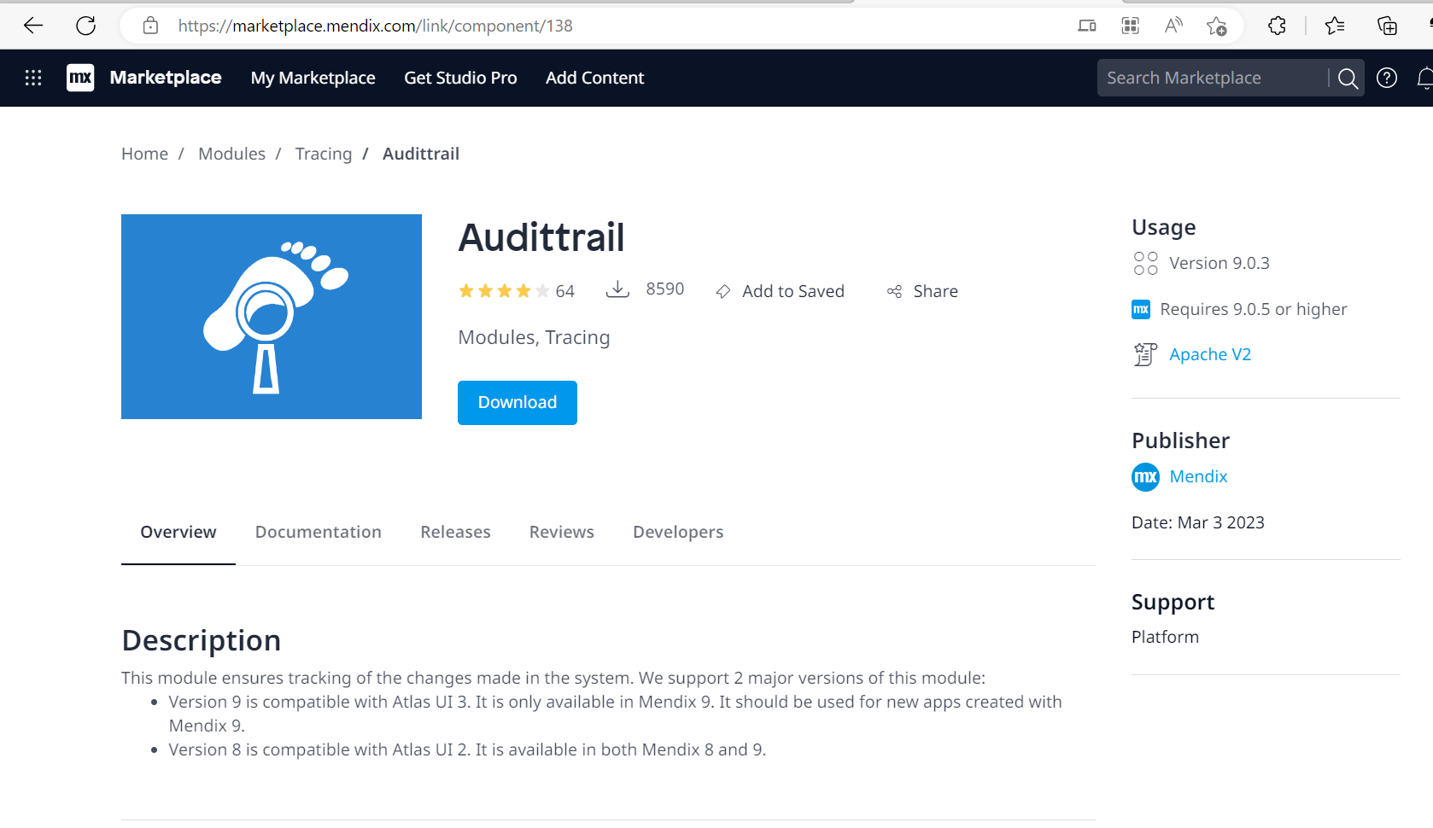

3.Import “ReusableDelegation_Helper” module in your app. (This module)

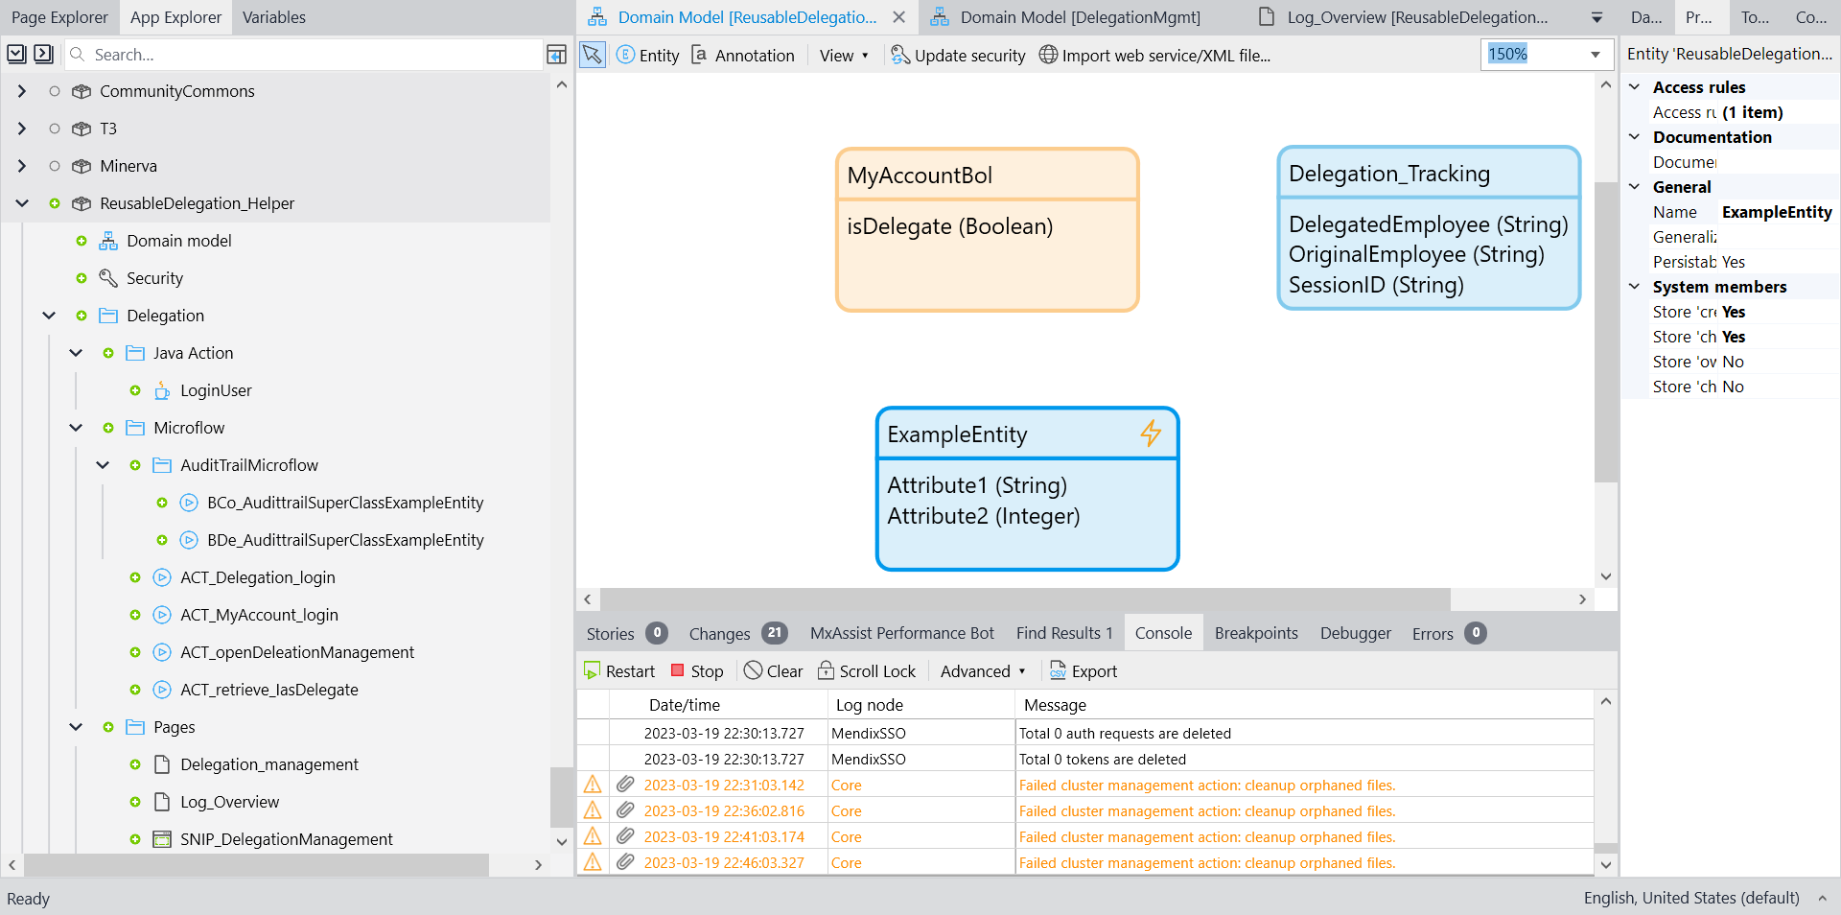

4.Add “ACT_openDeleationManagement” microflow to navigation or button .

5.

Delegation functionality is now working by completing above step.

Below step is for tracking the changes done by delegate person.

If changes is done by original person then no audit log will generate but if changes done by delegate person then audit log will be generate

(You can follow step by [Audit Trail | Mendix Documentation](https://docs.mendix.com/appstore/modules/audit-trail/)

Or

Follow below step )

If system member is not used in your entity then click on your entity and then Generalization then “AuditTrail. AudittrailSuperClass” entity and Eventhandler microflow make like AuditTrail microflow in ReusableDelegation_helper

But if system varible is used then

Make one to many association from “AuditTrail.Log” to your entity and in your entity make event handler like “ExampleEntity”

You need to add event hander like this your each entity

6. Grant role in app security

Delegation module have 2 role

Admin and User

Set role for 1.Audit trail, 2.delegation module and 3.ReusableDelegation_helper module